Guide to Using DE Gateway
Log in at https://degateway.gallatin.montana.edu/ and click on High School Student

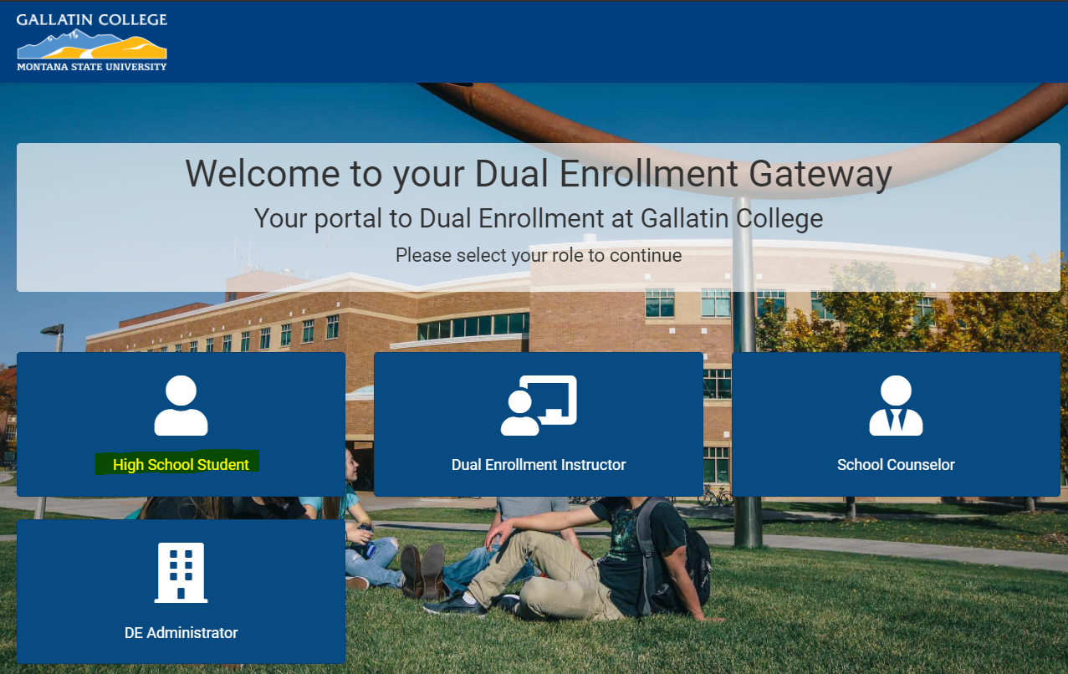

Login based on if you are a new student or a returning student.

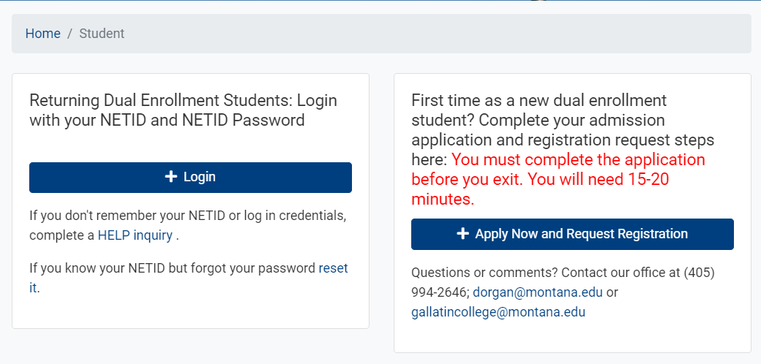

For new students, complete the registration information and click submit. Make sure you have 15-20 minutes to dedicate to this process.
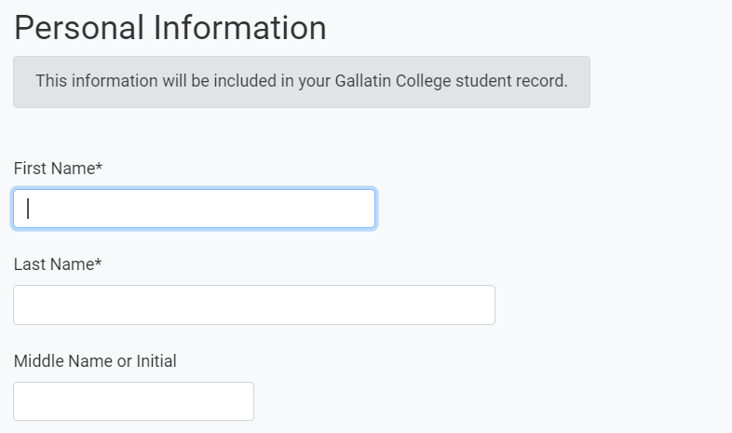

Sign the Student Agreement/FERPA consent:

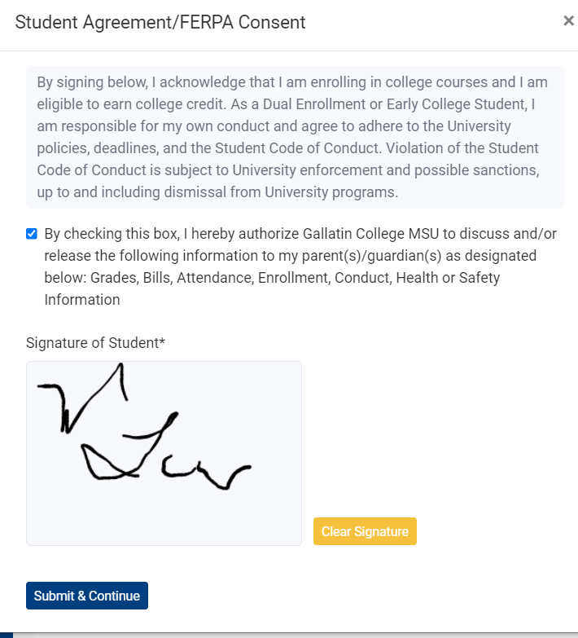

Select the course you are taking in your high school by clicking on the box next to the course, then click submit at the bottom of the page.
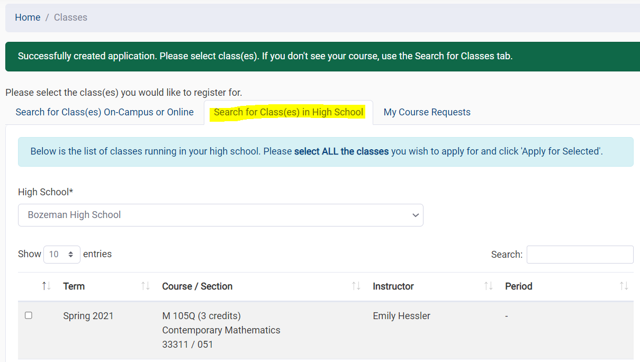

Next, click on Parent Consent, double check your parent information and click Submit Parent Consent Request Email:
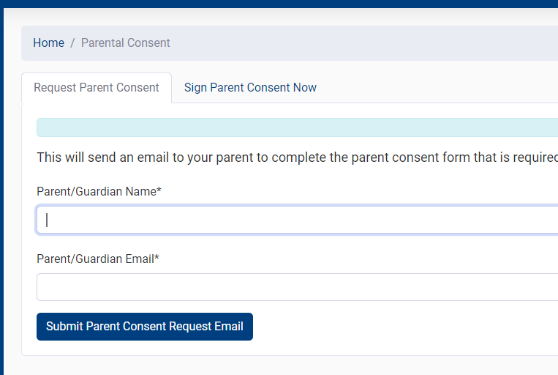
*this sends an email to your parent/guardian so they can complete the process.

OR, if your parent/guardian is with you while you are completing this form, click on Sign Parent Consent. Once you’ve completed the parent consent request, or had your parent sign immediately, you will start receiving notifications from the college.
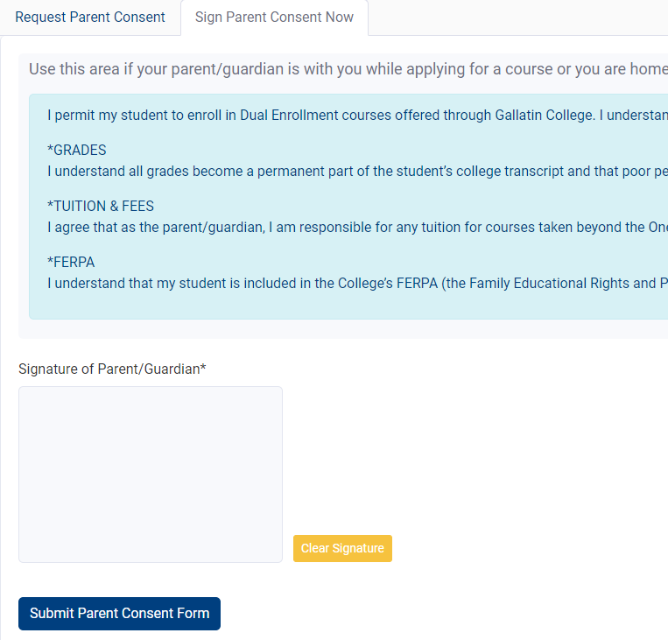
*This enables your parent/guardian to complete this step immediately.

If you click on the Home area, you can see a dashboard of the system. In the screenshot below, you will see that this student hasn’t completed the parent consent, so it is highlighted in pink. On this dashboard, you will also be able to see your student ID number, any announcements from the college, and be able to manage your profile.
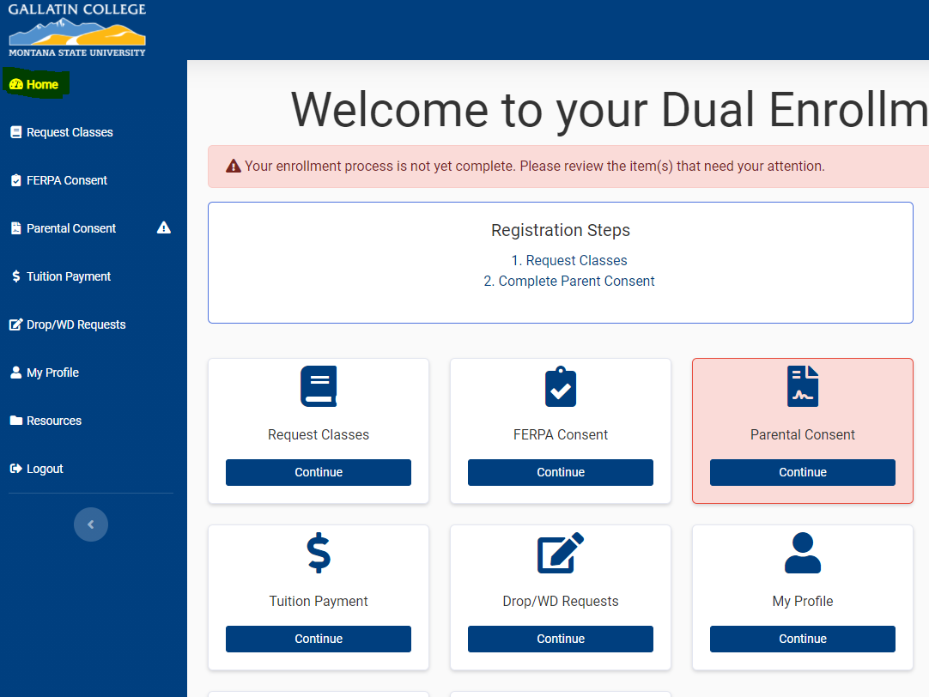

You will receive an email from the Dual Enrollment team once you’ve been officially registered. If there are any questions, we will be in touch.

